COS30015 IT Security
You will need:
Kali (VM)
CYSCA2014InABox (VM)
Windows 95 (VM)
A computer with internet access

Lab 3 (week 3)

In this lab you will experiment with Buffer overflows in the C language.

1. Using VMware Workstation Pro, start up the COS30015 / Kali Linux.
Don't need root. Now that we know a bit about security models, we're going to implement the principle of least privilege. user is a restricted account.
Select Other… if needed
Log in as user (user)
COS30015user (password)

Let's write a C program:

Start the editor thus:

pico memtest1a.c

Type in the following code:

/* memtest1a.c*/
#include <stdio.h>
#define SIZE 8
void test(int*, char*);
int main(){
int i = 0;
char buf[SIZE];
printf("Type in 5-20 chars into the text buffer\n");
printf("Watch the value of i \n");
printf("it will be corrupted when you exceed %i chars\n",SIZE);
printf("Type \"q\" to exit:\n");
printf("\t| i posn\t| buf start\t| buf end\t| i value\n");
do {
test(&i, buf);
i++;
}while(buf[0] != 'q');
return 0;
}
void test(int *j, char* buf){
scanf("%s",buf);
printf("OK.\t| %u\t| %u\t| %u\t| %d\n",j, buf, &buf[SIZE],*j);
return;
}

Use
Control+O to write to file (followed by ENTER)
Control+X to exit

Compile thus:

gcc –o memtest1a memtest1a.c

When the function is called, i is passed by reference. The test function can access this variable.
buf, being an array, is passed by reference, so the memory location is shared between the main function and test.

and run: ./memtest1a

Where in memory (the address) is i? What is its value?

 | Location (posn) | Comments
i | 3214664412
buffer start | 3214664404
buffer end | 3214664412
buffer size | 8
Bytes between buffer start and i | 8

Each string entered is appended with a NULL characters (a 0 byte). If you type 8 characters, a 9th character (the NULL) will overflow the array and write over adjacent memory. If this memory is in use, it gets corrupted.

(“i” basically should increment by 1 for each new input)

Play with the program (type stuff into it) and record your observations here:

Test No (i) | Text typed into buf | Number of characters | Behaviour
0 | 12345678 | 8 | 0
1 | 1234567890 | 10 | 12345
2 | 1234567890123 | 13 | 842084409
3
4
5
6
7
8

When a buffer fills up, it writes forwards or backwards depending on the CPU and operating system.

Type in a few strings smaller than 10 characters – note that the integer i is counting correctly.

What is the distance (in bytes) between buffer start and i?
If you try this in RedHat, the memory locations are further apart – about 13 bytes will overflow the LSB of i
n = (&i - buffer start) =
8

Try inputting that many characters (n) to overwrite the variable i.
Try it. Does i change?
If it crashes, just start it up again and keep typing longer strings. Watch the value of i.

Yes, it doesn’t increase at all when it is 8 characters

Try inputting n + 1 characters to overwrite the variable i.
Try it. Does i change?

It says 57

If a string is really long, you will crash the program (Linux will report a Segmentation Fault).
Code can be injected into the window between buffer overflow and segmentation fault, overwriting other parts of the program such as the return address and the EBP

More background here:
http://www.tenouk.com/Bufferoverflowc/Bufferoverflow2a.html
On Intel architecture, the last name overflows over the first name. It's different on other CPUs. That's why crackers want to know about the hardware.
2. Try this program:

/* memtest2.c*/
#include <stdio.h>
int main() {
char first[12];
char last[12];
printf("Type in your first name: ");
gets(first);
printf("Type in your last name: ");
gets(last);
printf("Hello %s %s\n", first, last);
return 0;
}

The compiler warning about gets will not stop compilation. You can ignore it.

Unlike scanf, gets lets you type in spaces and other non-printing characters, so is allows an attacker to enter executable code.

If you put in long strings, you can overflow one string with the contents of the other. If they are big enough, you will get a segmentation fault. If the size is just right, you will overwrite a function somewhere else in the program.

How many characters must you input into the last name to overwrite the first name (try it)?

12

3. You can also try these programs in Windows using the Quincy IDE (in the Win95 VM). If a 'segmentation error' occurs, Windows will pop up this message:

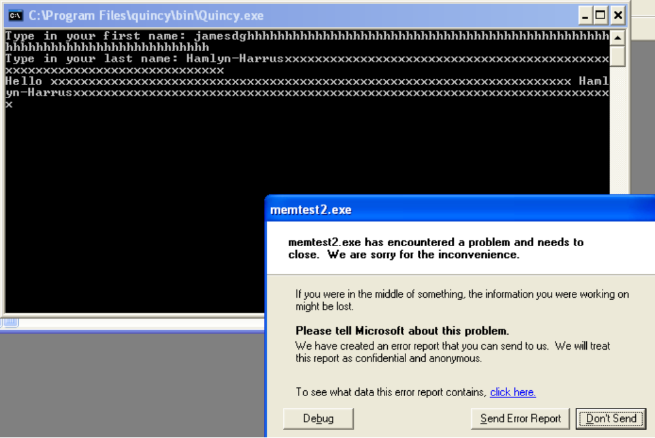

If you click on click here, you will see the contents of the stack pointer, which contains the hex value of some of the string you typed in.

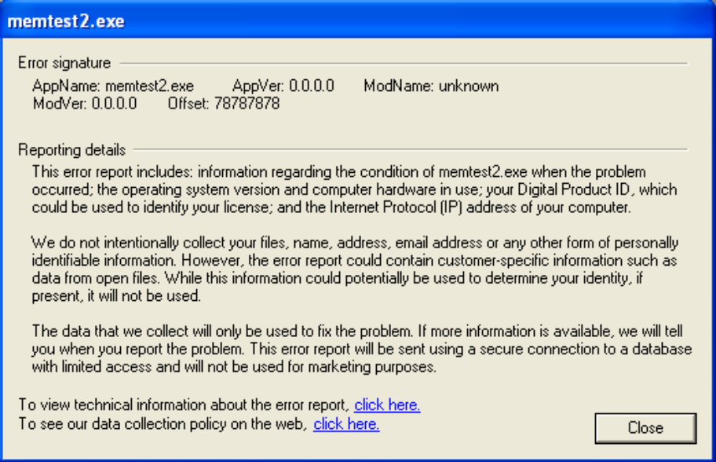

Note: 78787878 is hex for xxxx.

Hackers can use this feedback message to figure out which bytes in their exploit string will be copied into the stack pointer. Changing these critical bytes to the location of some (of their) executable code allows the exploit to run their code. With Linux, it's a bit harder, but not much.

4. Re-write memtest1.c or memtest2.c to prevent excess characters being pasted into the char arrays:

HINT:

replace scanf("%s") with scanf("%10s")---in the test function part also for printf’s %u and %d for j values
and %12 for the 2nd task
replace gets with fgets(x,12,std)
usage: char * fgets ( char * str, int num, FILE * stream );
eg. fgets(first, 12, stdin)

Unlike gets, fgets leaves characters in the keyboard buffer.
In windows you can clean up the input stream with
fflush(stdin);
In Linux you can do the same with
char ch; /*declare once only*/
while ((ch = getchar( )) != '\n' && ch != EOF);
example code in safegets.c
on Blackboard.

5. Using Google, look up the various "safe" string manipulating functions available in C. (e.g. strncpy, strncat)
What does the n do?

Limits the maximum number of character

How is value of n determined?

Buffer size?

6. Start up the COS30015 / CYSCA2014InABox
Surf to http://192.168.100.210
Click on CHALLENGES
Scroll down to Exploitation
Read the details of "The Fonz".
Click on the c file (let it open in GVim), and examine the code.

Note that two arrays DestBuffer and FixedVariable are adjacent to eachother. If we can overflow DestBuffer we might be able to write into adjacent variables.

On the host PC, open a browser and go to https://github.com/CySCA/CySCA2015/blob/master/corporate_network_pentest/files/chaff/assessments/Light%20Reading/CySCA2014_Exploitation.pdf
Don't use the web browser – you can't do interactive input. Netcat (nc) is a universal Telnet-like client suitable for this.

Follow the Walk-through for "The Fonz". Open a command window and launch netcat:
nc 192.168.100.210 20000

Sending a bunch of A's confirms that the overflow works.

What is the reported contents of FixedVariable?
0x41414141

Connect again and send a series of characters (alphabet) – you can "read" the position of FixedVariable by observing which characters get sent back.

Follow the walkthrough.
nc 192.168.100.210 20000
ABCDEFGHIJKLMNOPQRSTUVWXYZ

What is the reported contents of FixedVariable?
54535251
HINT-look them up on an ASCII table at asciitable.com on the host PC.
What ASCII characters do these HEX values represent?
TSRQ

Follow the instructions.

The server wants 0x73696851, which when converted to ASCII and reversed is?

sihQ

Try it out:

nc 192.168.100.210 20000
ABCDEFGHIJKLMNOP<your 4 chars answer here>
ABCDEFGHIJKLMNOPsihQ

What's the key?
CombatBrownieSwell366

7. On the host PC, surf to http://www.vividmachines.com/shellcode/shellcode.html
and read up on injecting shellcode into Linux and Windows processes.

What does . GetProcAddress() do?

Call the messageboxA function?

8. Using Google, look for tools and programs for checking a C program for potential buffer overflow vulnerabilities and memory leak testers. What are the names of some?

Memcheck by Valgrind, GCeasy, Eclipse MAT, PVS-Studio, GlowCode, AQTime by smartbear, WinDbg, BoundsChecker, Deleaker, etc from https://www.softwaretestinghelp.com/memory-leak-detection-tools/

,

9. Shut down all VMWare images
and browsers and log off.

End of Lab.

